Formal Diction

📘 What is Formal Diction
# Source: AI Source: Provided by: [Data Path: Persons Table -> ID Column: 1, Name_En Column: Motasem Essam] -> From: [Chatgpt (GPT-4-turbo)] on [7/30/2025]
Formal diction is the use of elevated, professional, and grammatically precise language that avoids slang, contractions, and colloquial expressions. It is typically used in academic writing, official documents, speeches, and ceremonial language.

✅ Key Features:
# Source: AI Source: Provided by: [Data Path: Persons Table -> ID Column: 1, Name_En Column: Motasem Essam] -> From: [Chatgpt (GPT-4-turbo)] on [7/30/2025]
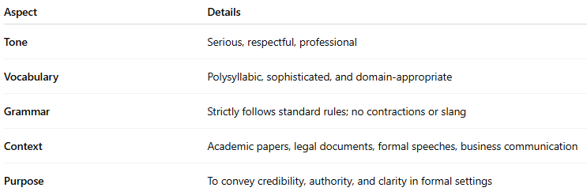
Aspect | Details
Tone | Serious, respectful, professional
Vocabulary | Polysyllabic, sophisticated, and domain-appropriate
Grammar | Strictly follows standard rules; no contractions or slang
Context | Academic papers, legal documents, formal speeches, business communication
Purpose | To convey credibility, authority, and clarity in formal settings

🧠 Examples:
# Source: AI Source: Provided by: [Data Path: Persons Table -> ID Column: 1, Name_En Column: Motasem Essam] -> From: [Chatgpt (GPT-4-turbo)] on [7/30/2025]
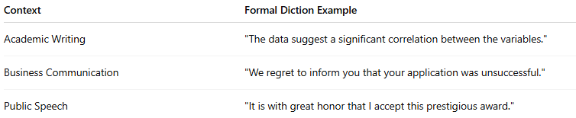
Context | Formal Diction Example
Academic Writing | "The data suggest a significant correlation between the variables."
Business Communication | "We regret to inform you that your application was unsuccessful."
Public Speech | "It is with great honor that I accept this prestigious award."

❌ Avoids:
# Source: AI Source: Provided by: [Data Path: Persons Table -> ID Column: 1, Name_En Column: Motasem Essam] -> From: [Chatgpt (GPT-4-turbo)] on [7/30/2025]
- Slang: ✘ “cool,” “wanna,” “guy”
- Contractions: ✘ “can’t,” “it’s,” “they’re”
- Informal phrases: ✘ “kinda,” “gonna,” “a lot”

📌 Comparison with Other Diction Types:
# Source: AI Source: Provided by: [Data Path: Persons Table -> ID Column: 1, Name_En Column: Motasem Essam] -> From: [Chatgpt (GPT-4-turbo)] on [7/30/2025]
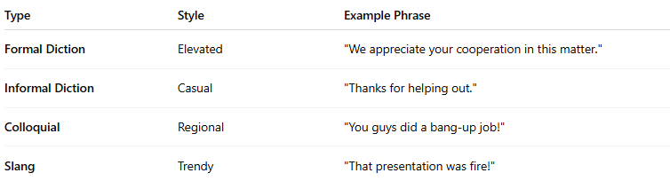
Type | Style | Example Phrase
Formal Diction | Elevated | "We appreciate your cooperation in this matter."
Informal Diction | Casual | "Thanks for helping out."
Colloquial | Regional | "You guys did a bang-up job!"
Slang | Trendy | "That presentation was fire!"

